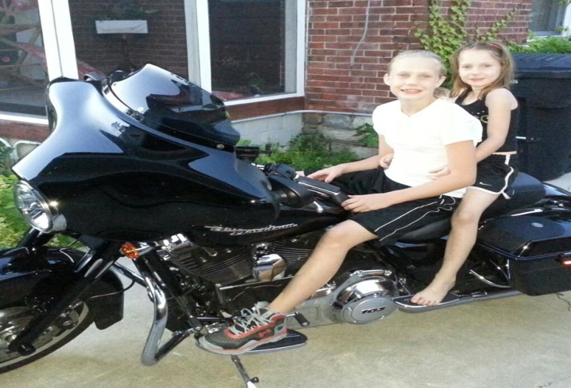[](http://www.google.com/url?sa=i&rct=j&q=&esrc=s&source=images&cd=&cad=rja&uact=8&docid=C-daOsNMxAVXlM&tbnid=XuTSST_TXO7ukM:&ved=0CAUQjRw&url=http://en.wikipedia.org/wiki/Golf_ball&ei=AdLfU9XHO8-jyASp2YLYBw&bvm=bv.72197243,d.aWw&psig=AFQjCNFCjG3eIgPRsqAgzgVFZGKShN7TnQ&ust=1407263593981425)

Mulligans for Marcia

[http://mulligansformarica.weebly.com](http://mulligansformarica.weebly.com/)

**Motorcycle Ride and Golf Outing**

**Norwood’s Golf Club**

**Motorcycle Run-Begins and ends at Norwood’s Golf Club**

9am Registration

10am Kickstands up

$15 per Rider, $5 per Passenger

Open to the public, with or without a bike.

**Golf Outing**

1pm Golf Registration

2pm Tournament Begins

$60 per person (includes 1 mulligan, drinks while golfing and dinner)

Additional mulligans-$5 each

*Please submit registration by September 26, 2014

**Food and Live Entertainment**

Bake Sale throughout the day

6:30pm Dinner and Auction

Meals are $5, and open to the public

Live Entertainment featuring Roustabout

Saturday, October 11, 2014

5961 W Maple Grove Rd.

Huntington, IN

**Please join us at Norwood’s Golf Club to help support Marcia Anders in her fight against Lung Cancer. Marcia is a mother and granny to many. She has touched many lives and continues to do so. Let’s help give back to her.**

Live Entertainment

Featuring

Roustabout

Raffle drawings

Door Prizes

And more

For questions, please contact Kandi Camomile 260-355-8577 or Missy Norris 260-224-1368

All proceeds raised will go towards helping Marcia in her battle against cancer. All proceeds are a charitable tax donation. If you would like a tax receipt please include the following: Contact name, address, city, state, Zip and email address

*This space could be  
used for customer  
testimonial quotes,   
or points of interest*

* List your services or products here.
* List your services or products here.
* List your services or products here.
* List your services or products here.
* List your services or products here.

ph

fx

Street Address

Suite 555

City, State 55555

555.555.5555

555.555.5555

email@address.com

www.webaddress.com

PLACE PHOTO HERE,

OTHERWISE DELETE BOX

Type your call-out text here. Consider including customer testimonials or information   
on what you do here

Insert List Here.

COMPANY Name here

